­­­-

Vyshak S Bekal 241059045 [MAHE-MSIS]

Linux Lab 3 Assignment

Vyshak S Bekal

241059045 M.E - Cyber Security MSIS, MAHE

1. Print all the lines with the pattern “they”

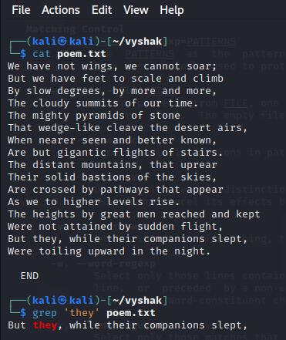

1. Print all the lines other than pattern “They”

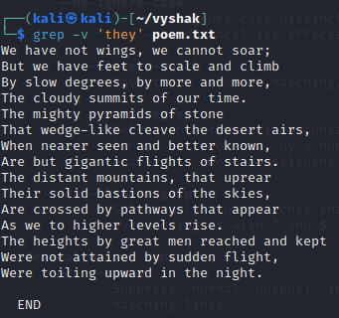

1. Print all the lines starts with “w”

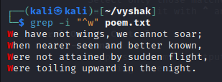

1. Print the next lines after the pattern “stone” matches

Hint: man grep

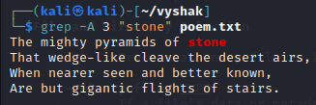

1. Print the 2 lines above the pattern “stone” matches

Hint: man grep

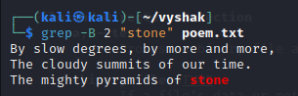

1. Search the pattern with exact match

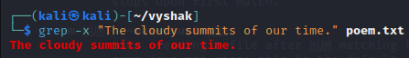

1. Explore variations of grep command
2. Ngrep - Used for network packet filtering based on pattern matches.
3. Pgrep - Searches for processes matching a pattern.
4. Zgrep - Searches within compressed files.
5. egrep - Extended grep allowing additional regular expressions like +, |, etc.
6. Write a shell script to get the pattern and filenames from the user and check whether the pattern is present or not.

#!/bin/bash

echo "Enter the pattern:"

read pattern

echo "Enter the filename:"

read filename

if grep "$pattern" "$filename"; then

echo "Pattern found"

else

echo "Pattern not found"

fi

1. Rewrite the above shell script using command line arguments. ( pass the pattern and file through command line arguments)

#!/bin/bash

pattern=$1

filename=$2

if grep "$pattern" "$filename"; then

echo "Pattern found"

else

echo "Pattern not found"

fi

1. Write a shell script to count total number of regular files in the current working directory.

#!/bin/bash

find . -type f | wc -l

1. pipe
2. Pick the line from 3 to 5.

sed -n '3,5p' poem.txt

1. List the top 5 largest files in a directory and display their sizes

ls -lS | head -5

1. Print the last 2 modified file details

ls -lt | head -3

1. Redirection
2. Convert uppercase into lowercase characters

tr '[:upper:]' '[:lower:]' < inputfile > outputfile

1. List the contents of your current directory, including the ownership and permissions, and redirect the output to a file called contents.txt within your home directory.

#!/bin/bash

while IFS= read -r line; do

echo "$line"

done << EOF

$(grep "pattern" filename)

EOF

1. Rewrite the shell script (3) using <<

ls -l > ~/contents.txt

“You don't have to see the whole staircase, just take the first step.”

― **Martin Luther King Jr.**